**Excel Assignment - 9**

**1. What are the different margins options and do we adjust the margins of  
the excel worksheet?**  
To use predefined margins, click Normal, Wide, or Narrow. Tip: If you previously used a custom margin setting, that setting is available as the Last Custom Setting option. To specify custom page margins, click Custom Margins and then—in the Top, Bottom, Left, and Right boxes—enter the margin sizes that you want.

**2. Set a background for your table created.  
Add a sheet background**

Click the worksheet that you want to display with a sheet background. Make sure that only one worksheet is selected. On the Page Layout tab, in the Page Setup group, click Background. Select the picture that you want to use for the sheet background, and then click Insert.

**3. What is freeze panes and why do we use freeze panes? Give  
examples.**  
When you freeze panes, Excel keeps specific rows or columns visible when you scroll in the worksheet. For example, if the first row in your spreadsheet contains labels, you might freeze that row to make sure that the column labels remain visible as you scroll down in your spreadsheet.

**4. What are the different features available within the Freeze Panes  
command?**  
Whenever you're working with a lot of data, it can be difficult to **compare** information in your workbook. Fortunately, Excel includes several tools that make it easier to view content from different parts of your workbook at the same time, including the ability to **freeze** **panes** and **split**your worksheet.

Optional: Download our [**practice workbook**](https://media.gcflearnfree.org/content/5c09830877c05003547285b0_12_06_2018/excel_freezepanes_practice.xlsx).

Watch the video below to learn more about freezing panes in Excel.

To freeze rows:

You may want to see certain rows or columns all the time in your worksheet, especially **header cells**. By **freezing** rows or columns in place, you'll be able to scroll through your content while continuing to view the frozen cells.

1. Select the **row**below the row(s) you want to **freeze**. In our example, we want to freeze rows **1** and**2**, so we'll select row**3**.

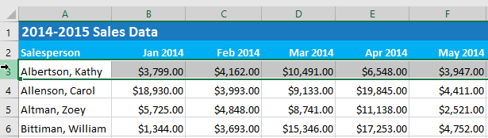

1. On the **View** tab, select the **Freeze Panes** command, then choose **Freeze Panes** from the drop-down menu.

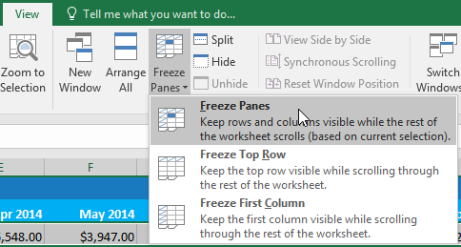

1. The rows will be **frozen** in place, as indicated by the **gray** **line**. You can **scroll down** the worksheet while continuing to view the frozen rows at the top. In our example, we've scrolled down to row **18**.

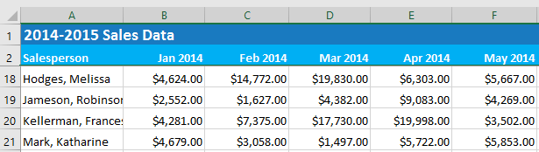

To freeze columns:

1. Select the **column** to the right of the column(s) you want to **freeze**. In our example, we want to freeze **column A**, so we'll select column **B**.

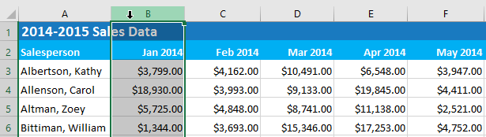

1. On the **View** tab, select the **Freeze Panes** command, then choose **Freeze Panes** from the drop-down menu.



1. The column will be **frozen** in place, as indicated by the **gray line**. You can **scroll across** the worksheet while continuing to view the frozen column on the left. In our example, we've scrolled across to column **E**.

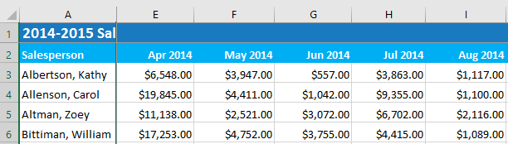

If you only need to freeze the**top row** (row 1) or **first column** (column A) in the worksheet, you can simply select **Freeze Top Row** or **Freeze First Column** from the drop-down menu.

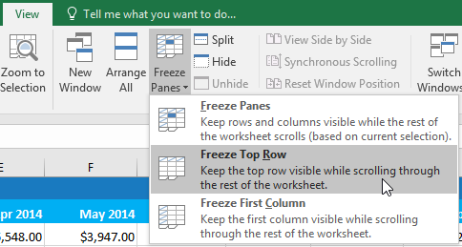

To unfreeze panes:

If you want to select a different view option, you may first need to reset the spreadsheet by unfreezing panes. To **unfreeze** rows or columns, click the **Freeze Panes** command, then select **Unfreeze Panes** from the drop-down menu.

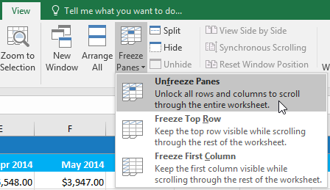

**5. Explain what the different sheet options present in excel are and what  
they do?**  
It allows us to organize vast amounts of data across multiple sheets. Every Excel workbook has at least one sheet. By default, when we create a new Excel file, it usually has three sheets, namely Sheet1, Sheet2, and Sheet3. Furthermore, we can add or delete the desired number of sheets accordingly.